Bootstrap Layout Tasks (Grid, Nested Columns, Navbar)

Task 1 — 3 Column Responsive Layout
Code:
<div class="container mt-5">
<div class="row">
<div class="col-lg-4 col-12 bg-primary text-white p-3">Column 1</div>
<div class="col-lg-4 col-12 bg-success text-white p-3">Column 2</div>
<div class="col-lg-4 col-12 bg-danger text-white p-3">Column 3</div>
</div>
</div>

OUTPUT:
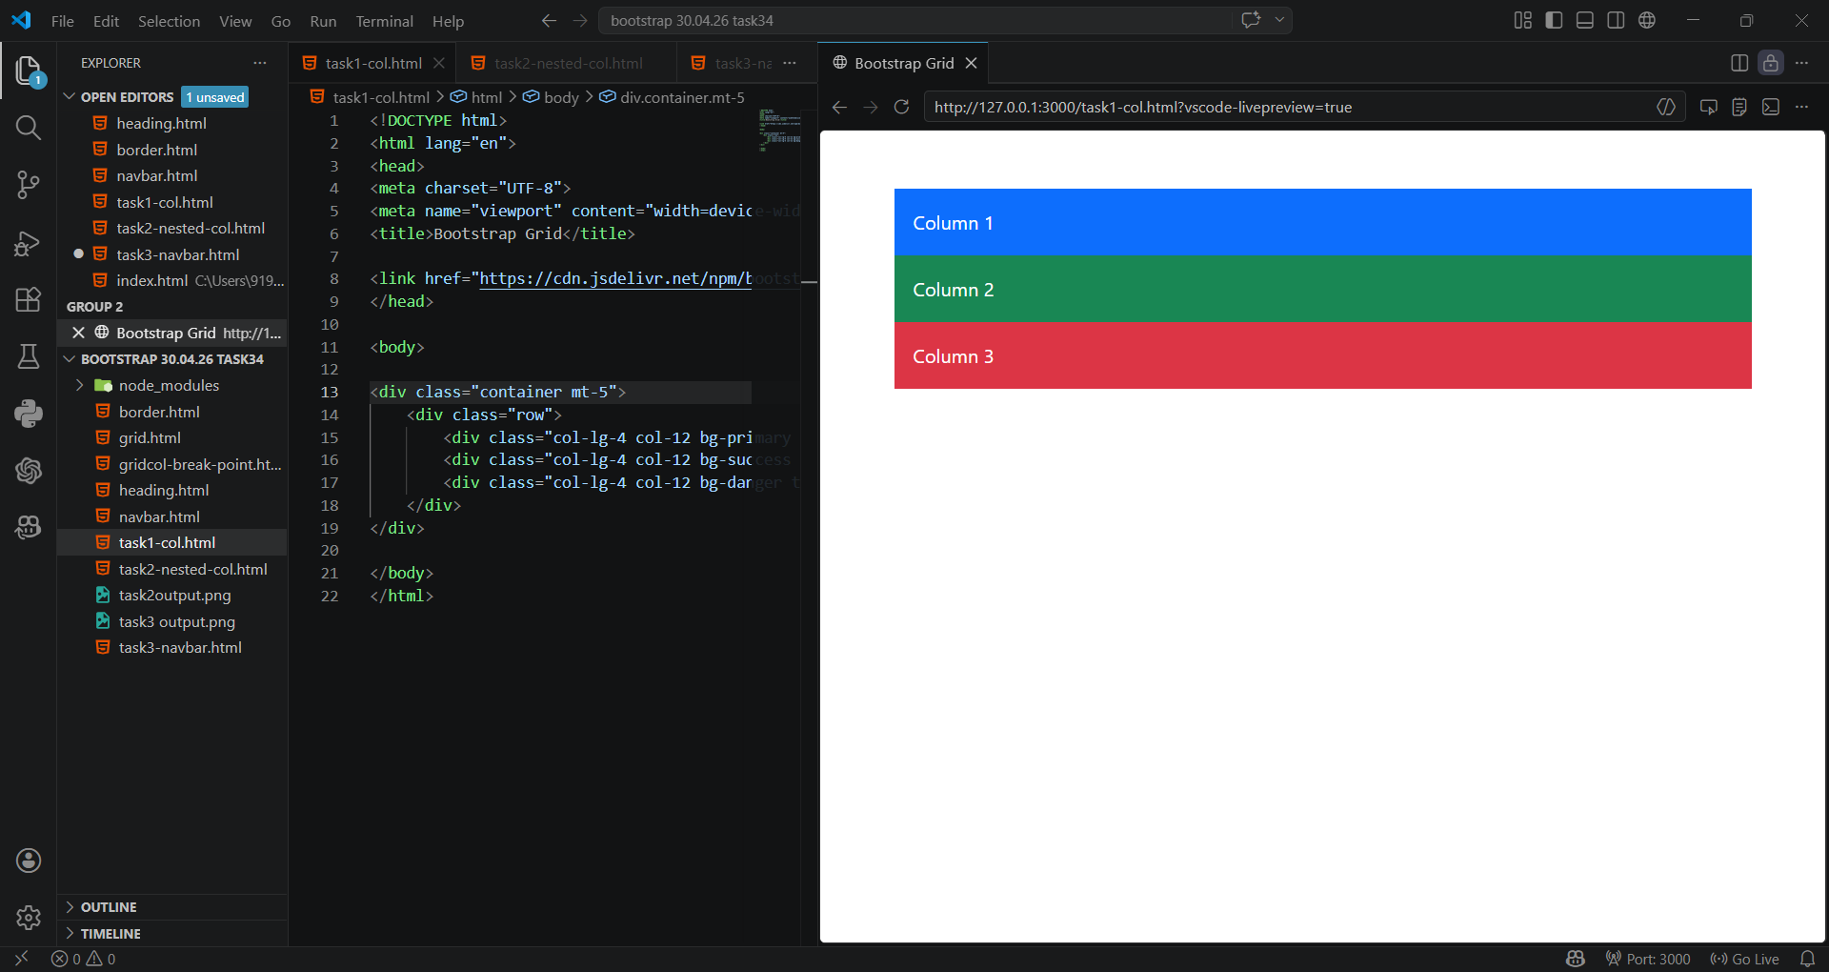
Task 2 — Nested Columns
Code:
<div class="container mt-5">
<div class="row">
<div class="col-lg-4 bg-primary text-white p-3">Column 1</div>
<div class="col-lg-4 bg-success text-white p-3">
<div class="row">
<div class="col-6 bg-warning text-dark p-2">Sub 1</div>
<div class="col-6 bg-info text-dark p-2">Sub 2</div>
</div>
</div>
<div class="col-lg-4 bg-danger text-white p-3">Column 3</div>
</div>
</div>

OUTPUT:
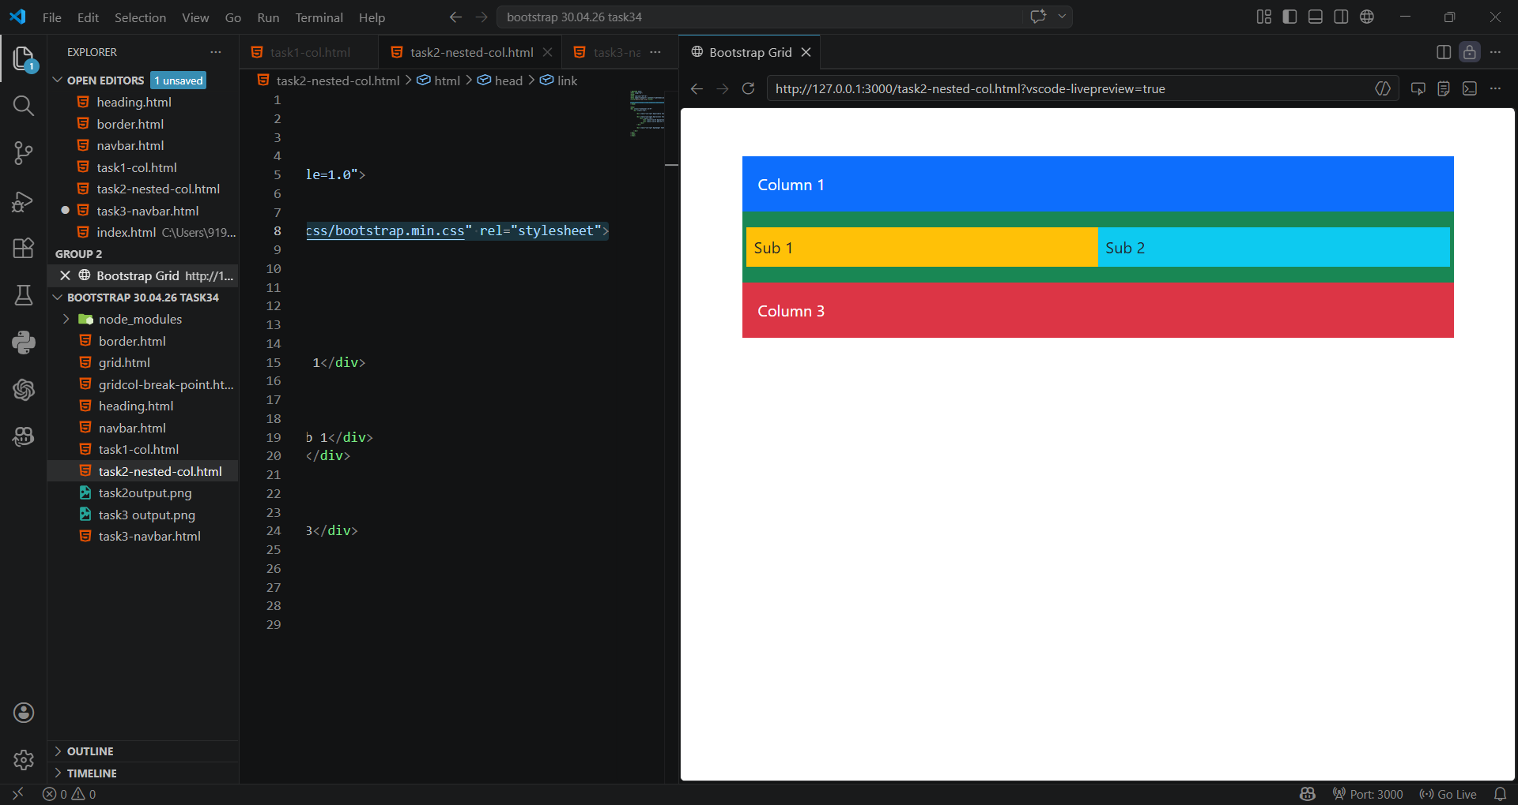
Task 3 — Responsive Navbar
Code:
<nav class="navbar navbar-expand-lg navbar-dark bg-dark">
<div class="container">
<a class="navbar-brand" href="#">MySite</a>
<button class="navbar-toggler" type="button" data-bs-toggle="collapse" data-bs-target="#menu">
<span class="navbar-toggler-icon"></span>
</button>
<div class="collapse navbar-collapse" id="menu">
<ul class="navbar-nav ms-auto">
<li class="nav-item"><a class="nav-link" href="#">Home</a></li>
<li class="nav-item"><a class="nav-link" href="#">About</a></li>
<li class="nav-item"><a class="nav-link" href="#">Contact</a></li>
</ul>
</div>
</div>
</nav>
OUTPUT:
